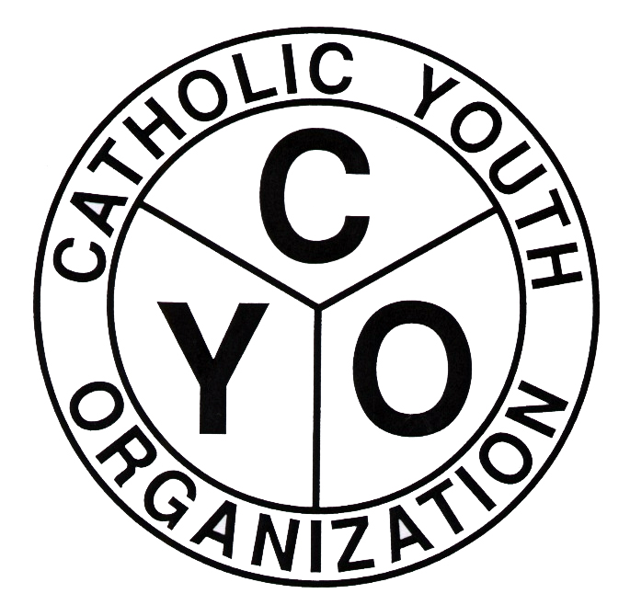
CATHOLIC YOUTH ORGANIZATION
Diocese of Brooklyn
7200 Douglaston PKWY – Douglaston, NY 11362
Tel: 718.281.9548/ Fax: 718.281.9557

2019-2020 CYO SWIMMING TEAM INFORMATION SHEET
PLEASE PRINT OR TYPE ALL REQUIRED INFORMATION
BOYS_____________ GIRLS ___________________
1. NAME OF TEAM _______________________________________________________________________
2. NAME OF PARISH, ADDRESS, PHONE # & PASTOR/AD:
(If COMBINED Team, list ALL Parishes represented):

__________________________________________________________________________________________________
3. *HEAD COACH____________________________________________________________________________________
PHONE #_________________B#_______________CELL # _________________E MAIL____________________________
*This will be the person contacted when problems arise, such as weather cancellations, eligibility issues, etc., and to whom ALL MAILINGS will be sent.
4. *ASSISTANT COACHES:
NAME/PHONE PARISH LEVEL (N, B, J, S)
_____________________________________________________________________________________
_____________________________________________________________________________________
_____________________________________________________________________________________
_____________________________________________________________________________________
_____________________________________________________________________________________
_____________________________________________________________________________________
_____________________________________________________________________________________
_____________________________________________________________________________________
_____________________________________________________________________________________
_____________________________________________________________________________________
______________________________________________________________________________________

5. * LOCKER ROOM PARENTS:
NAME/PHONE PARISH
_____________________________________________________________________________________
_____________________________________________________________________________________
_____________________________________________________________________________________
*All Coaches and Locker Room Parents listed on this form must have completed a VIRTUS session.

6. MARSHALLS:
NAME/PHONE PARISH
_____________________________________________________________________________________
_____________________________________________________________________________________
_____________________________________________________________________________________
This form must be completed and returned with your entry form by:
- BOYS TEAMS: October 11, 2019
- GIRLS TEAMS: December 13, 2019

Revised 9/16/19

